|  |
| --- |
| Dr. USMAN ABBASI |
| Computer Organizational and Assemble language-LAB |
| Lab manual-1 |

|  |
| --- |
| ARMGHAN AHMAD  9/24/2021 |



**Lab manual 1**

Objectives:

In today’s lab we are going to discuss about what is assemble language and how computer interacts with human. How our commands/codes are converted into in to machine language and how our data is access form RAM and also how data is allocated in RAM. Also we have talked about NASM & MASM, how they works.

We have also downloaded & installed MASM in the lab and print HELLO WORLD on the screen. And following are the steps how we have download and install.

Step 1:

After we have downloaded MASM successfully now installation is easy, by just clicking YES and OK. We can easily install MASM in our system.

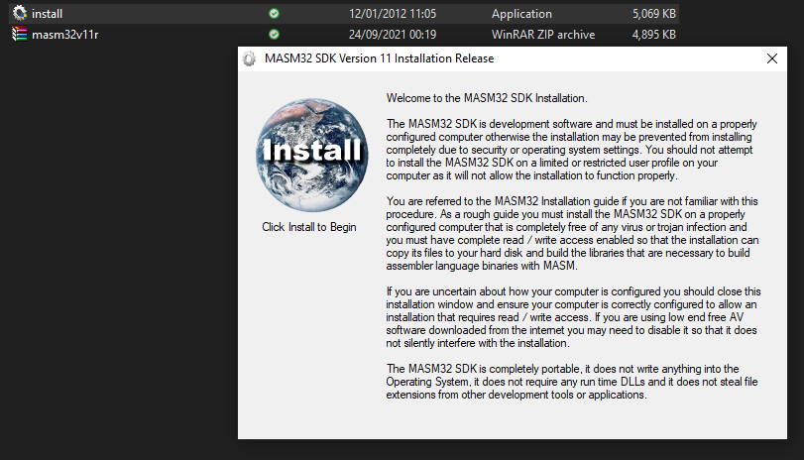

Step 2:

Click OK

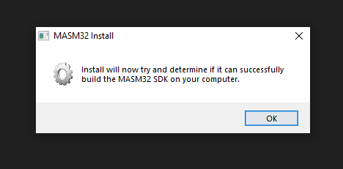

Step 3:

Click OK

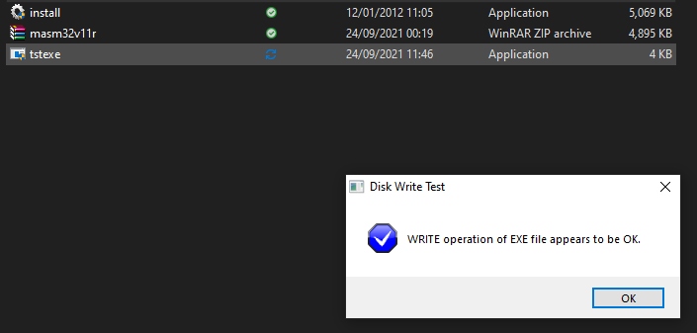

Step 4:

Click OK

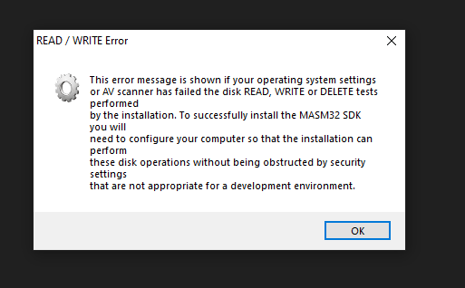

Step 5:

Wait while extracting MASM on hard disk

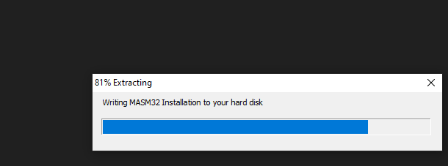

Step 6:

Click OK

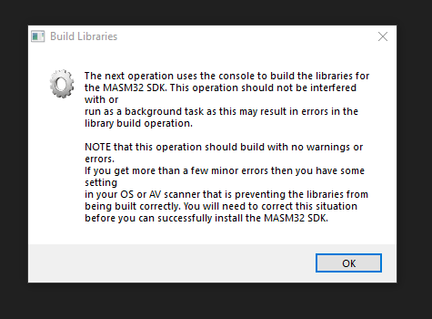

Step 7:

After 7 – 8 steps command prompt will open and there some files and libraries are installed.

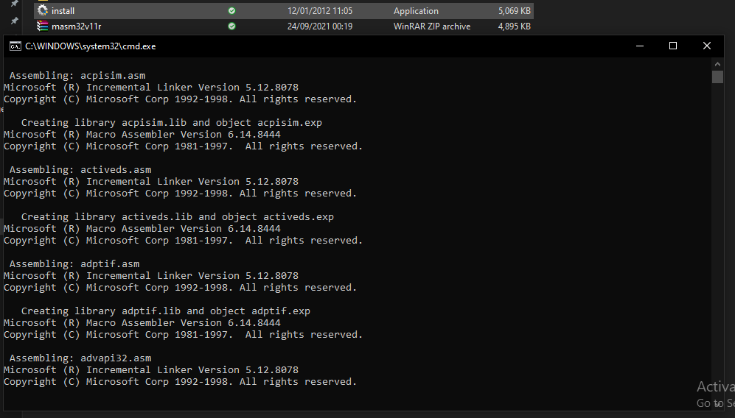

Step 8:

Installation successfully

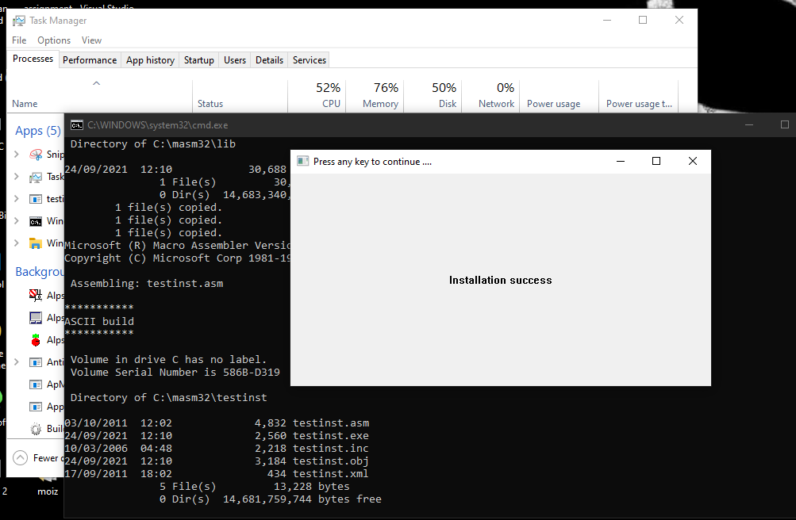

Step 9:

Click YES

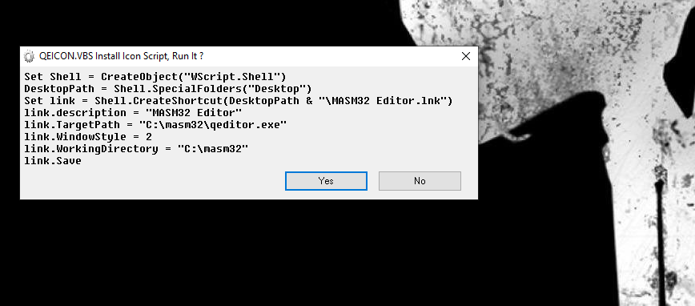

Step 10:

Click OK.

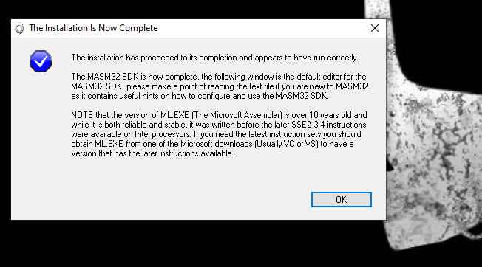

Step 11:

Now our MASM has installed successfully and shortcut icon is displayed on desktop. And after clicking on icon we can seen this window which is MASM interface. After that we can run our code on it.

